How to Edit Top Navigation

Step 1.
- Go to http://www.touchingheart.com/admin/
- username: Dmitry password: Dmitry2013
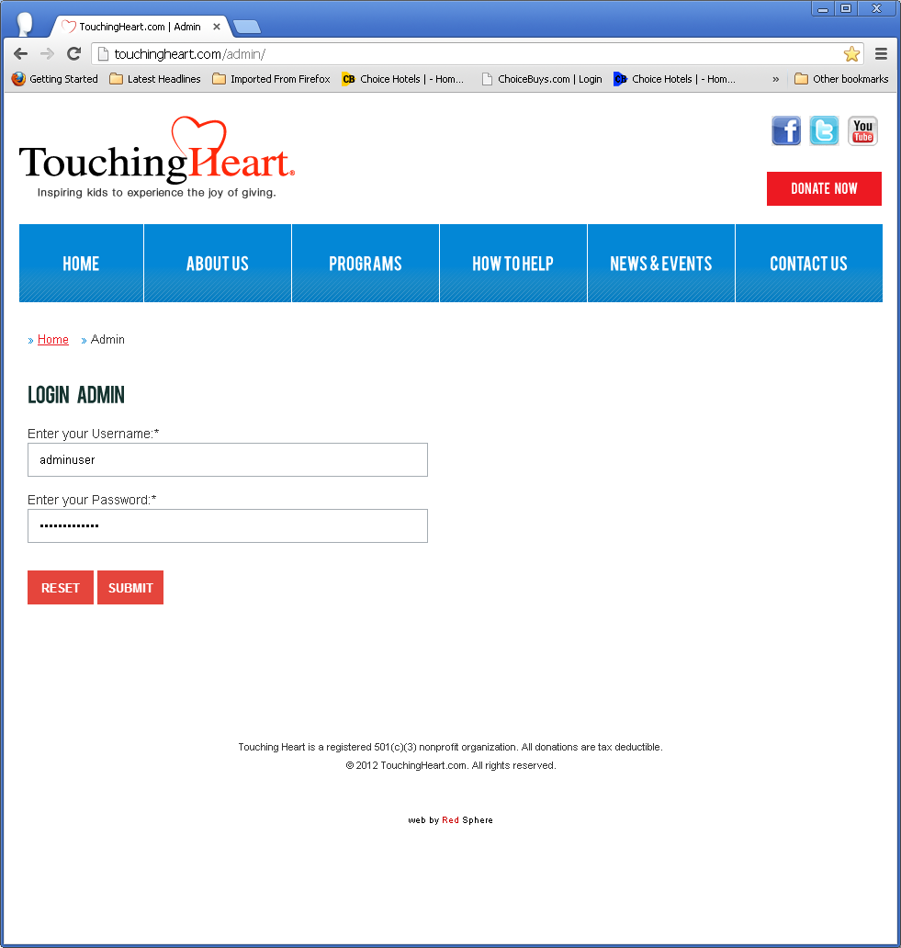
Figure 1

Step 2.
Once you are logged in, click “edit” Top Navigation. (Figure 2)
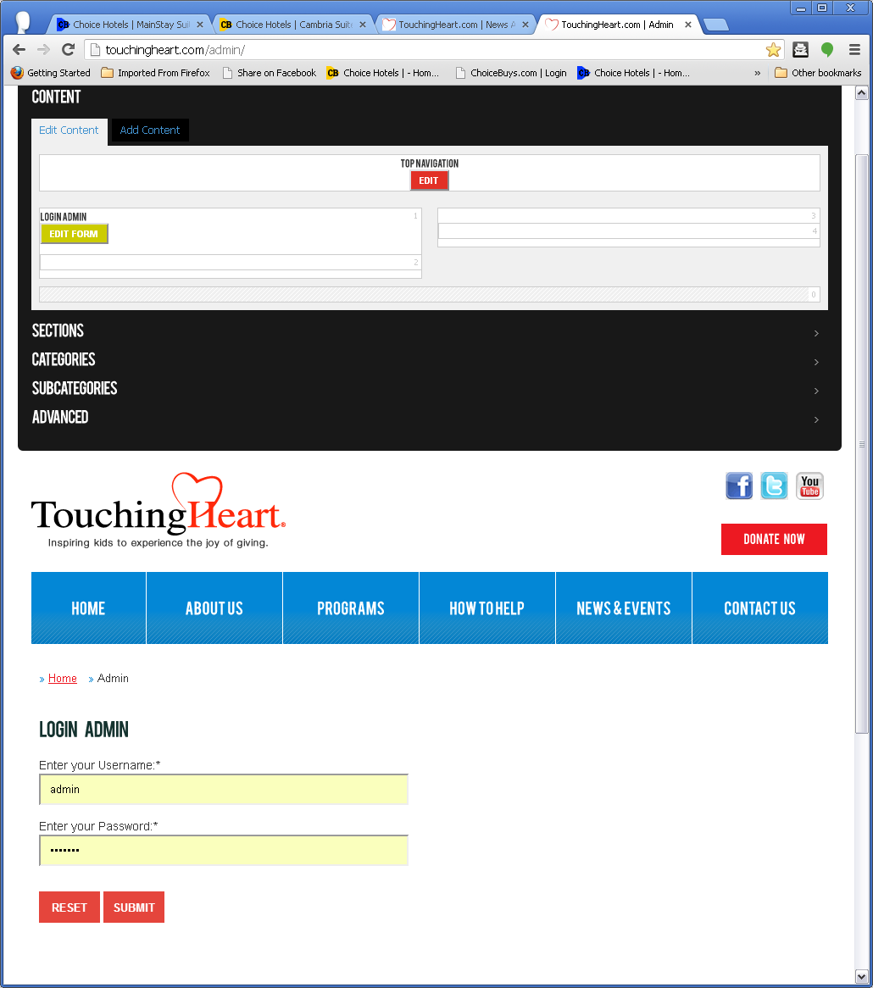
Figure 2

Step 3.

Edit
To edit, click any of the Buttons in the Menu Item Manager to expand and see available options. (Figure 3)
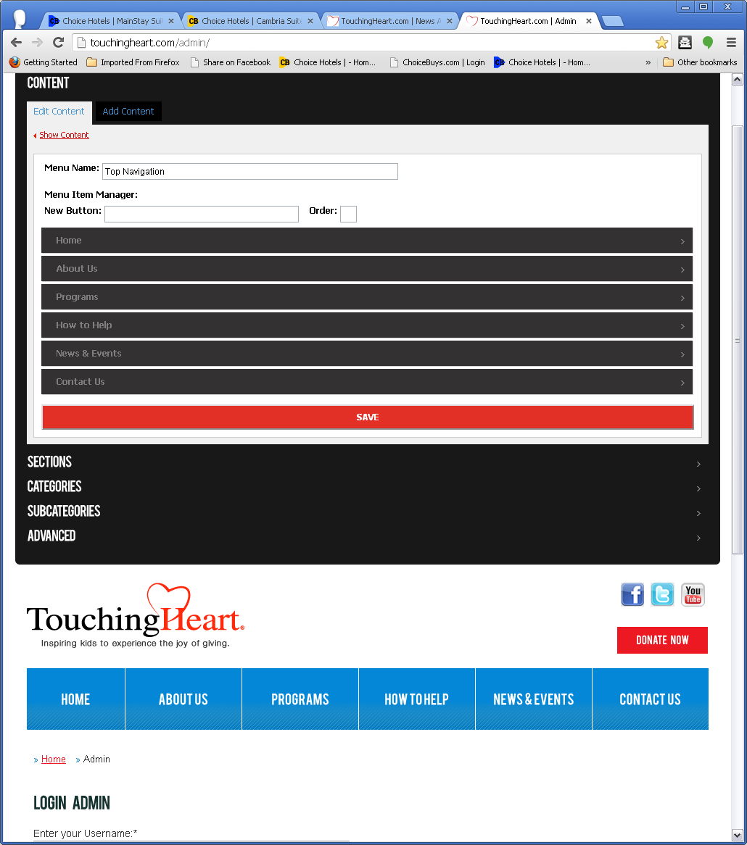
Figure 3
Initially, you are presented with the following options. Button and Sub-Button(s) (Figure 4)
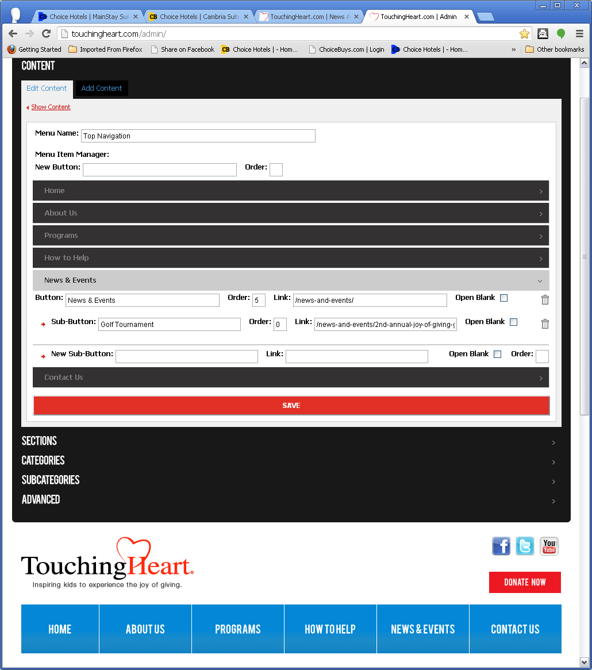
Figure 4

Button
Button: Enter the main Button tag name.
Order: Enter the order number in which this button must show within the menu.
Link: Enter the link. Not mandatory.
Open Blank: Check to open link in New Window.
Trash can icon: Delete the button. (!!)

Sub-Button
Sub-Button: Enter the sub-button tag name.
Order: Enter the order number in which this sub-button must show within the button.
Link: Enter the link.
Open blank: Check to open link in New Window.
Trash can icon: Delete the sub-button. (!)
To finish edition click ”Save”.

Add

New Button
To add a New Button, enter a tag name in “New Button”. Then press “Save”. (Figure 5)
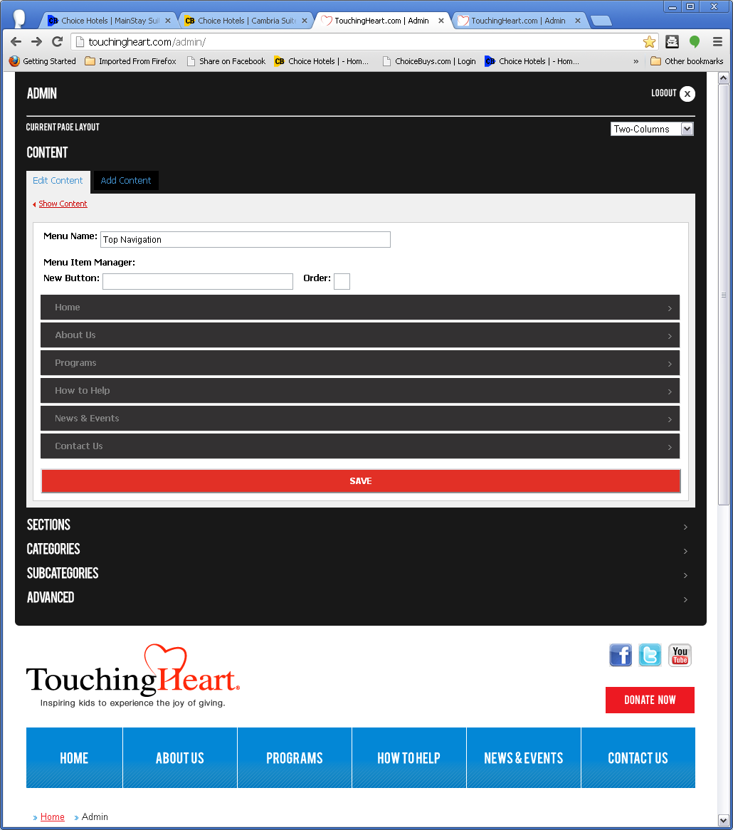
Figure 5

Sub-Button
To add a New Sub-Button, click any of the Buttons in the Menu Item Manager to expand. (Figure 6)

Figure 6

New Sub-Button
New Sub-Button: Enter the sub-button tag name.
Link: Enter the link.
Open blank: Check to open link in New Window.
Order: Enter the order number in which this sub-button must show within the button.
To finish click “Save”.

